Jeffery Crosby
2-14-12
Sue Briggs
ENGL 2010; T, TH 10:00-11:15
BEGINNING OF A CYBERTRONIC WAR
Outer space! A huge black abyss that has always fascinated peoples minds of all ages. People have always wondered what is out there in its depths to be discovered such as stars, black holes, or other planets with intelligent life. It has even been the topic of many movies, television shows, and books that has brought tremendous excitement. Imagine out in space a planet made entirely out of metal, its mechanical natives stand at about twenty feet tall or shorter with weapons of mass destruction. The trouble is that the mechanical giants are divided into two teams: one good and the other evil, which are at war for control of their home. Just who are these robotic beings exactly?
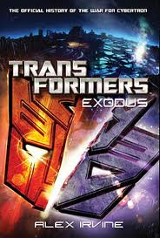
These gigantic robots are the Transformers of the planet “Cybertron.” As all fans know, Transformers is about a robot alien race that’s divided into two teams: Autobots (led by Optimus Prime) and Decepticons (led by Megatron) bent on fighting for the universe. Transformers were created by Takara Tomy which came on television in 1984 and is still running to this day. (“Transformers”) Due to its relevant success much merchandise has been created such as action figures, movies, and even books. Seven books in total have been written but the one that fans should read to learn about the series origins is the four star rating book: Transformers Exodus by Alex Irvine. (“Transformers: Exodus”) From this book fans will get to learn about how the war started, enjoy reading about campaigns that led to the desertion of their home, and seeing connections to the movies. But just what led to the cause of these battles in the start of the war?
War is a very serious topic of today with the talk of the conflict going on in Iraq which was started from the fall of the World Trade Center. Still to this day soldiers of the United States remain at battle in hopes of bringing peace and protection to their country. Well just like the events of nine-eleven which lead to war, Transformers Exodus will reveal the same thing for the cybertronic war. Since the creation of Transformers, thousands of fans have always been curious on just how the war broke out between the Autobots and Decepticons. Well they are about to get their answer, which will leave all readers exasperated for they won’t ever forget a tale of supposed betrayal and brotherhood.
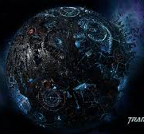
The government of Cybertron isn’t exactly the best (caste system) which could lead to an uprising rebellion led by a gladiator tyrant who dreams of making the planet a place where Cybertronians can be free. This robot warrior eventually catches the attention of a robot data clerk that notices they share the same appeals. They meet each other and develop a friendship which causes them feel like brothers and bring their views of the system to the governmental leaders. What was there ruling? Let’s just say that it involves the title of “Prime” and one furious gladiator brother that vows to lead the rebellion to victory. (Irvine 1-111) From this point on it’s nothing but straight battles which unfortunately causes the decimation of Cybertron.
The Planet Cybertron
When going to war soldiers have to ready to battle against their enemy. The thing is that nobody can really predict when the fight will end and who will be victorious. But a major problem that results from all the conflicts on the battle field is that the location could end up a barren wasteland and people will have to leave their native homeland. This was the exact result for both the Autobots and Decepticons of Cybertron. Who without a doubt from their continuous fighting, had brought chaos and destruction to their planet. Along with the discovery of something dark and evil that was the final part to the desertion of the robot home world.
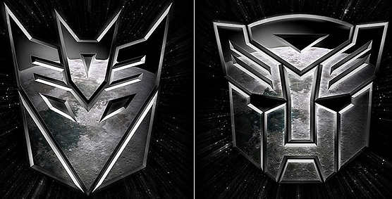
“Autobots roll out!” “Decepticons mobilize!” The famous battle cries of both Optimus Prime and Megatron when they’re leading their troops into battle. In Transformers Exodus, fans that read this book can expect to follow their favorite characters such as Soundwave, Shockwave, Starscream, Sideswipe, Ironhide, and Bumblebee into great battles with much action that’ll get them to imagine being a robot and battling against the enemy of their opposing side. Readers will also get to experience all sorts of battle locations on Cybertron such as a mechanical park full of amusement, mountain regions with fortresses, and even a city made of glorious colorful shards which will leave individuals surprised that a comparison of the planet will be made to that of Earth. (Irvine) But in the end, the Decepticons control most of the planet while so little is possessed by the Autobots. Megatron then decides to finish the war once for all by using a dark energy of pure evil but as always, the Autobots stop this heinous act and are granted victory. As a result of the corruption, both sides now must leave and journey to find the AllSpark which will then bring them to their future home planet, “Earth.” (Irvine 112-276)
Decepticon and Autobot Symbols
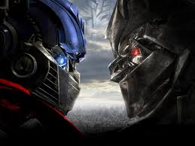
Transformers has been a very successful television trilogy since its first generation that other generations having been created for fans’ amusement such as Beast Wars, Robots in Disguise, and Transformers: Prime. These shows unfortunately attracted much attention with their humor, characters, and action that three movies were produced and came to big screens. But what do the movies (mostly the first one) have to do with the story in Transformers Exodus? The answer is that this book is a connecting prequel to first film. In this book, quite a few answers to questions by fans on the first movie are discovered in this epic story. Such as the leadership of Optimus and Megatron, how they were brothers, the cause behind Bumblebee’s silence, and ejection of the AllSpark into space. So if a big fan of Transformers and have seen the movies, then go ahead, read this book and get answers to all questions to the first movie of the franchise.
Optimus Prime and Megatron
Transformers have always been a very popular show that books have been written in honor of all its success. One that every fan should indeed read is Transformers Exodus. This book greatly describes the cause of the war in great detail, along with outstanding descriptions of the early battles between the Autobots and Decepticons which led to them leaving their home, and even bring answers to questions about the first movie. Overall, out of a one to five rating, Transformers Exodus deserves a five with all the action that takes place among the robots and telling of what led up to the start of the war on Cybertron. May there always be Transformers for there’s more than meets the eye!
WORKS CITED
- Irvine, Alex. Transformers: Exodus. New York: Del Rey Books, 2010.
- “Transformers.” Wikipedia. N.p., n.d., Web. 14 Feb. 2012
- “Transformers: Exodus: The Official History of the War for Cybertron.” Barnes and Noble. n.p., n.d., Web. 14 Feb. 2012

